Google Summer of Code - 2026

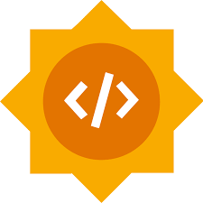

Subcommand CLI for GRASS



Proposed by Arth Patel

GSoC 2026

Subcommand CLI for GRASS

Proposed by Project Category
Arth Patel Subcommand CLI for GRASS | Difficulty: Hard | 350 hours
Full Name
Arth Parikshit Patel
Email
arth200patel@gmail.com
GitHub
https://github.com/ArthPatel1502
LinkedIn
https://www.linkedin.com/in/arthpatel15/
University
The Charutar Vidya Mandal (CVM) University
Primary Mentor
Vaclav Petras
Co-Mentors
Stefan Blumentrath, Corey White
Draft PR
https://github.com/OSGeo/grass/pull/7216

Table of Contents
Abstract 3
Related Work 4
Project Overview 5
What I Built Before This Proposal 6
Architecture 9
Benefits to the Community 12
Deliverables 13
Project Timeline 15
Time Commitment and Conflicts 16
Studies 17
Biographical Information 18
GSoC History 19
AI Tool Disclosure 19
References 19

1.Abstract
The command-line interface of GRASS GIS is powerful but often requires users to manually manage projects, mapsets, and multiple intermediate steps before executing even simple analyses. Tasks such as importing data, setting the computational region, running a module, and exporting results must typically be performed as separate commands, making quick workflows unnecessarily complex and increasing the learning curve for new users.

This project aims to design and implement a structured subcommand-based CLI that simplifies how GRASS tools are executed. The core idea is to enable complete workflows to be performed in a single command, while internally handling data import, region configuration, module execution, and output export. For example, a workflow that currently requires multiple steps can be reduced to a single command such as:
grass run --import-raster=input.tif \
--region="raster=input" \ r.slope.aspect slope=output.tif

The project builds on the existing experimental CLI and extends it by introducing integrated file-based workflows, structured subcommands, and improved usability. Instead of relying on purely hardcoded aliases, the design will explore a combination of structured command patterns and automated handling of external data formats such as GeoTIFF and GeoPackage.

A clean Python-based abstraction layer will be developed underneath the CLI to ensure consistency, extensibility, and maintainability. This layer will manage session handling, command translation, and workflow orchestration while preserving full compatibility with the existing GRASS module system.
As part of initial exploration, I implemented a working prototype that demonstrates simplified command execution and end-to-end raster processing, including automated region handling and GeoTIFF output generation. This hands- on work provided practical insight into the current CLI limitations and validated the feasibility of the proposed approach.
The final outcome will be a user-friendly and extensible CLI that reduces complexity, improves productivity, and aligns GRASS GIS with modern command-line design practices, while maintaining the full power and flexibility of the existing system.
Here is the link to the draft PR: https://github.com/OSGeo/grass/pull/7216

Related Work
  - Existing GRASS CLI and Experimental Subcommands

GRASS GIS relies on a module-based command-line interface where users execute individual tools such as r.slope.aspect or g.list. This design provides flexibility and fine-grained control, but requires users to know exact module names and manually manage parameters, projects, and mapsets. As a result, even simple workflows involve multiple steps and commands.
An experimental subcommand interface (grass run) has been introduced to improve usability. However, it still exposes much of the underlying complexity and does not yet provide higher-level abstractions such as integrated data handling, simplified workflows, or structured command patterns.

  - CLI Design in Modern Tools

Modern command-line tools such as Git and Docker use structured subcommands (e.g., git commit, docker run) to organize functionality and improve discoverability. These systems abstract internal complexity while maintaining full control for advanced users.
This approach demonstrates that a well-designed CLI can significantly reduce cognitive load and improve usability without limiting functionality. The proposed Subcommand CLI for GRASS follows a similar design philosophy by introducing structured commands and workflow-oriented execution.

  - Python-Based Automation in GRASS

GRASS provides Python scripting capabilities through libraries such as grass.script, enabling users to automate workflows programmatically. While powerful, this approach requires explicit handling of environment setup, session initialization, and module execution.
For simple command-line usage, this introduces unnecessary complexity. The proposed CLI builds on these capabilities by providing a lightweight abstraction layer that internally manages sessions and execution, while exposing a simplified interface to the user.

  - Existing Gaps and Motivation

Despite existing tools and experimental features, the current CLI lacks a unified interface for executing complete workflows in a single step. Tasks such as importing data, setting computational regions, running analysis, and exporting results must still be performed separately.
In addition, handling external data formats such as GeoTIFF and GeoPackage requires explicit import or linking steps, which adds friction to common use cases.

This project addresses these gaps by extending the experimental CLI with structured subcommands and integrated file-based workflows. The goal is to enable users to run GRASS tools directly on external data and perform complete processing pipelines in a single command, while maintaining full compatibility with the existing system.

Project Overview
Currently, using GRASS GIS from the command line requires users to directly invoke individual modules such as r.slope.aspect or g.list, while also manually handling environment setup, including locations, mapsets, and computational regions. Although this design is flexible and powerful, it makes even simple workflows multi-step and time-consuming, especially for users working with external data formats such as GeoTIFF or GeoPackage.

An experimental subcommand interface (grass run) already exists, which provides a more structured way to execute modules. However, it still exposes much of the underlying complexity and does not yet support higher-level workflows such as directly operating on external files or combining multiple steps into a single command.
The goal of this project is to design and implement a structured Subcommand CLI that simplifies how GRASS tools are used, with a strong focus on workflow-oriented execution and direct handling of external data formats.
At a high level, the system enables users to run complete workflows in a single command. For example:
grass run --import-raster=input.tif \
--region="raster=input" \ r.slope.aspect slope=output.tif

Internally, this command performs multiple steps automatically:

Imports or links external data (e.g., GeoTIFF, GeoPackage) Sets the computational region based on input data
Executes the requested GRASS module
Exports results back to standard formats

To achieve this, the project introduces a Python-based abstraction layer on top of the existing GRASS CLI. This layer is responsible for:

Workﬂow Orchestration: Combining multiple GRASS operations (import region run export) into a single execution pipeline.
Command Structuring: Providing a more organized interface through subcommands and consistent command patterns, while remaining aligned with existing module naming.
Session Management: Automatically initializing and managing GRASS environments, removing the need for manual setup.
Data Handling: Supporting direct input and output of common geospatial formats such as GeoTIFF and GeoPackage.
Extensibility: Ensuring the system is modular so that additional subcommands, options, and workflows can be added in the future.

A key challenge of this project is maintaining full compatibility with the existing GRASS CLI while improving usability. Advanced users must retain full control over module execution, while new users benefit from simplified workflows and reduced setup complexity.
As part of initial exploration, I implemented a working prototype that demonstrated simplified command execution and end-to-end raster processing, including automatic region handling and GeoTIFF output generation. Based on mentor feedback, the project will further explore structured command patterns alongside file-based workflows to determine the most effective and scalable design.

What I Built Before This Proposal
Before starting this proposal, I focused on understanding how GRASS operates internally from the command line by setting up a local development environment on macOS (Apple Silicon) and working with the nc_spm_08_grass7 dataset. Instead of relying only on documentation, I explored how modules are executed, how sessions are managed, and how workflows are structured in practice.

While experimenting, I observed that even simple tasks require long and unintuitive commands such as:
grass /path/to/project --exec r.slope.aspect elevation=... slope=...

This highlighted that the main challenge is not functionality, but usability and workflow complexity.

To address this, I built a Python-based prototype that acts as a lightweight wrapper around the GRASS CLI. The goal was to simplify command execution and reduce multi-step workflows into a single interface.
In this prototype:

simplified commands such as g list and g slope are mapped to g.list and r.slope.aspect GRASS modules are executed programmatically using grass.script
environment handling is partially automated

This allowed commands such as:
g slope elevation=elevation.tif slope=slope.tif aspect=aspect.tif

to replace significantly longer GRASS commands.

I extended this prototype to support a complete workflow by integrating:

automatic region handling using g.region raster processing using r.slope.aspect
output export using r.out.gdal

This resulted in an end-to-end pipeline where a single command processes input data and generates a GeoTIFF output. The workflow was validated by successfully generating my_first_slope.tif.
Through this hands-on work, I developed a practical understanding of:

how GRASS modules are invoked internally
how sessions, mapsets, and computational regions are managed how Python (grass.script) interacts with the GRASS engine
where the current CLI introduces complexity in real workflows

As a next step, I integrated a basic version of this idea into the experimental CLI (grass run) by introducing command mapping and opened a draft PR to gather early feedback from mentors.
This exploration helped me identify that the core problem is not just command length, but the lack of a workflow- oriented interface. Based on mentor feedback, I will extend this work beyond simple alias mapping toward structured subcommands and direct file-based workflows, which form the foundation of the proposed Subcommand CLI design.
I actively contributed to the GRASS Addons repository by working on real issues related to testing and module maintenance.
I addressed Issue #975, where deprecated modules were still being included in automated tests, causing CI failures. I implemented a fix to properly exclude these modules from the test discovery process, which improved the reliability of the test suite. This work was submitted as Pull Request #1635.
I also worked on Issue #830, where I contributed improvements to the addon testing and module handling logic. This helped ensure better consistency and stability in how modules are processed within the repository. The solution was submitted as Pull Request #1559.

Through these contributions, I gained hands-on experience with:

Understanding the GRASS Addons repository structure Working with Python-based testing frameworks
Debugging CI failures and ensuring successful test runs
Following contribution workflows including branching, commits, and pull requests Interacting with maintainers and incorporating feedback
These contributions gave me practical exposure to the GRASS development ecosystem and helped me understand how modules, testing, and integration are handled. This experience directly informs my approach to designing and implementing the Subcommand CLI, ensuring that my work aligns with existing project standards and practices.

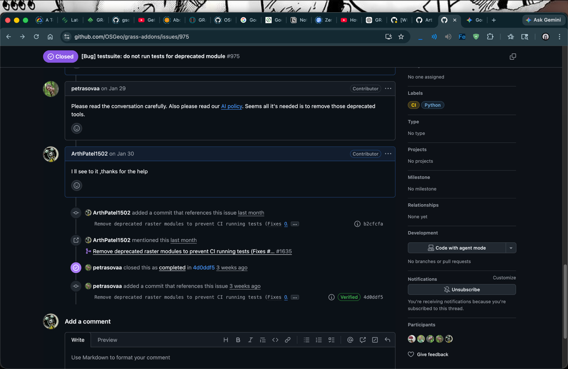
Issue No : 975
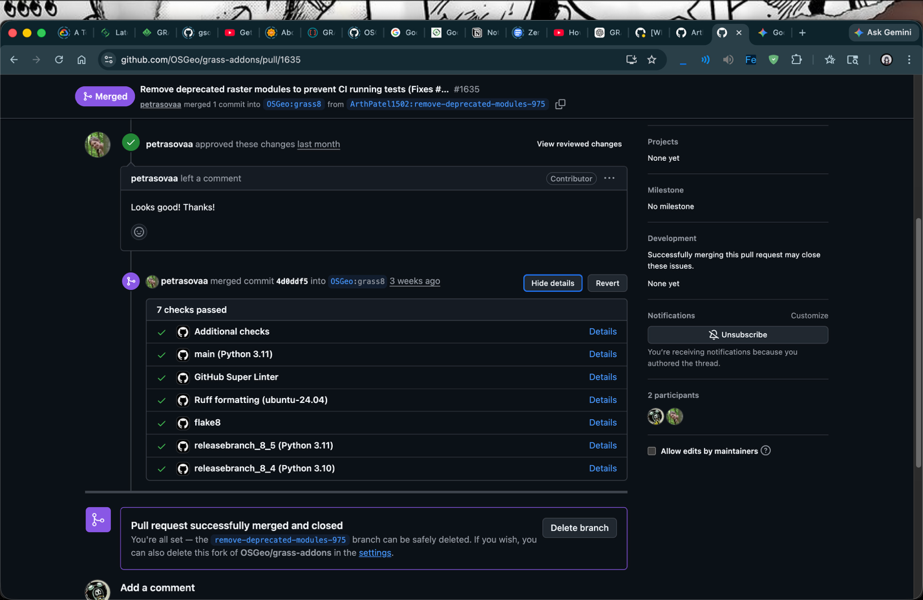
PR No : 1635
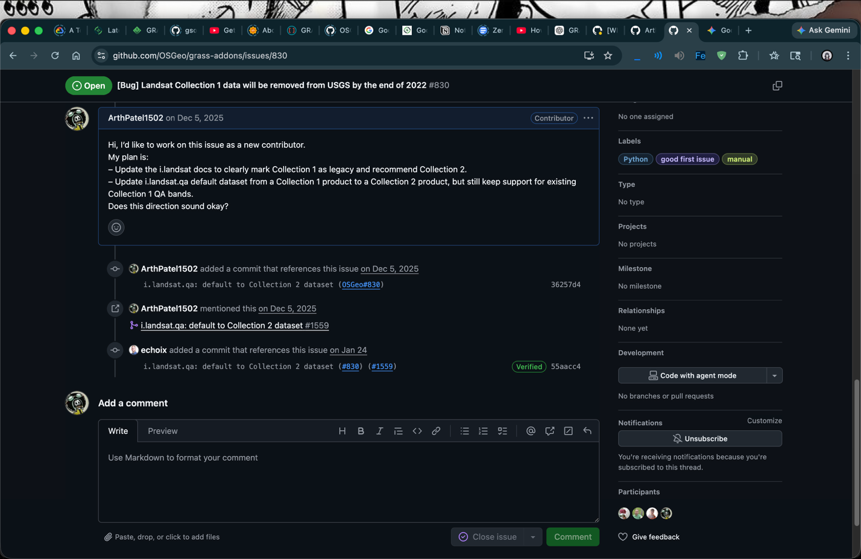
Issue No : 830
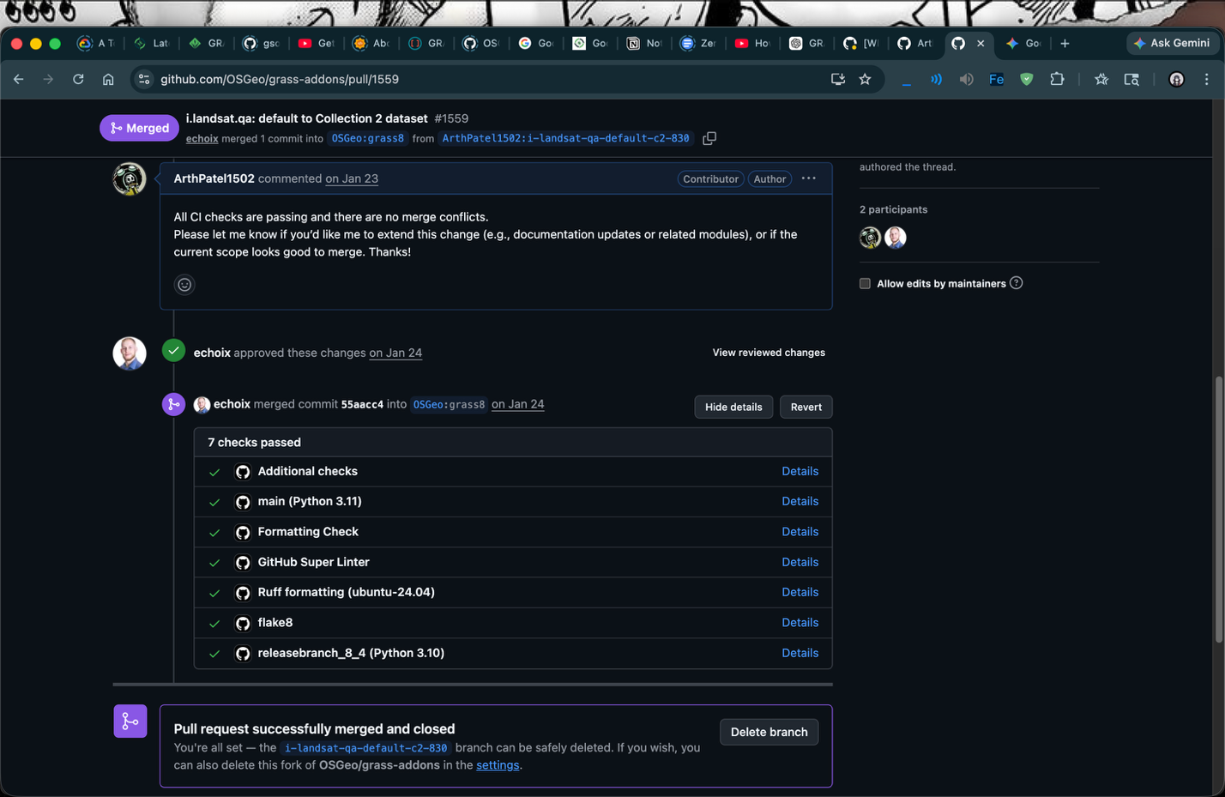
PR No : 1559

Architecture
  - Overall Design

The proposed Subcommand CLI introduces a structured abstraction layer on top of the existing GRASS CLI. Instead of directly invoking GRASS modules, users interact with a workflow-oriented interface that simplifies execution while preserving full compatibility.
At a high level, the architecture consists of three layers:
User Interface Layer (CLI Subcommands)
Handles user input such as:
grass run --import-raster=input.tif \
--region="raster=input" \ r.slope.aspect slope=output.tif
Command Processing Layer
Interprets user input, validates options, and prepares the execution pipeline. This includes structured command handling and optional command mapping.
Execution Layer (GRASS Engine)
Executes the resolved operations using the existing GRASS infrastructure.

  - Command Processing and Mapping

The command processing layer is responsible for translating user input into executable GRASS operations. This includes:
parsing subcommands and flags validating input arguments
optionally resolving simplified command forms

A lightweight mapping mechanism may be used where appropriate (e.g., simplifying repetitive commands), but the primary focus is on structured command patterns and workflow execution, rather than relying solely on hardcoded aliases.
This approach ensures better scalability and alignment with GRASS module naming conventions.

  - Execution Flow

The execution pipeline is designed to convert a single command into a sequence of GRASS operations:

    - Parse user input
    - Initialize GRASS session
    - Handle input data:
Import raster/vector (r.import, v.import) Link external data (r.external)
    - Configure computational region (g.region)
    - Execute target module
    - Export results (r.out.gdal, v.out.ogr)

This enables complete workflows to be executed in one step instead of multiple manual commands.

  - Session and Environment Handling

The system introduces an internal session manager that:

initializes GRASS environments automatically manages locations and mapsets
ensures consistent execution context

This removes the need for manual setup and reduces user errors.

  - Data-Oriented Command Extensions
To support direct workflows on external data, the CLI introduces integrated options such as: --import-raster=path.tif uses r.import
--link-raster=path.tif uses r.external
--region="raster=name" uses g.region

These options allow users to operate directly on GeoTIFF and GeoPackage files without intermediate steps.

  - Extensibility Design

The architecture is modular and extensible:

command processing logic is separated from execution
new subcommands and options can be added independently
supports future structured namespaces (e.g., grass raster, grass general) This ensures long-term maintainability.
  - Compatibility and Parity
Maintaining compatibility with the existing GRASS CLI is a key requirement. The system ensures: all existing modules remain accessible
advanced usage is preserved
the new CLI acts as a higher-level interface, not a replacement

  - Validation Through Prototype
A working prototype has already been implemented to validate the approach. It demonstrates: simplified command execution
automated workflow (region processing export)
successful generation of GeoTIFF outputs

Initial experimentation focused on command mapping, which helped in understanding CLI behaviour. Based on mentor feedback, the design is now evolving toward structured commands and file-based workflows, which form the core of this architecture.

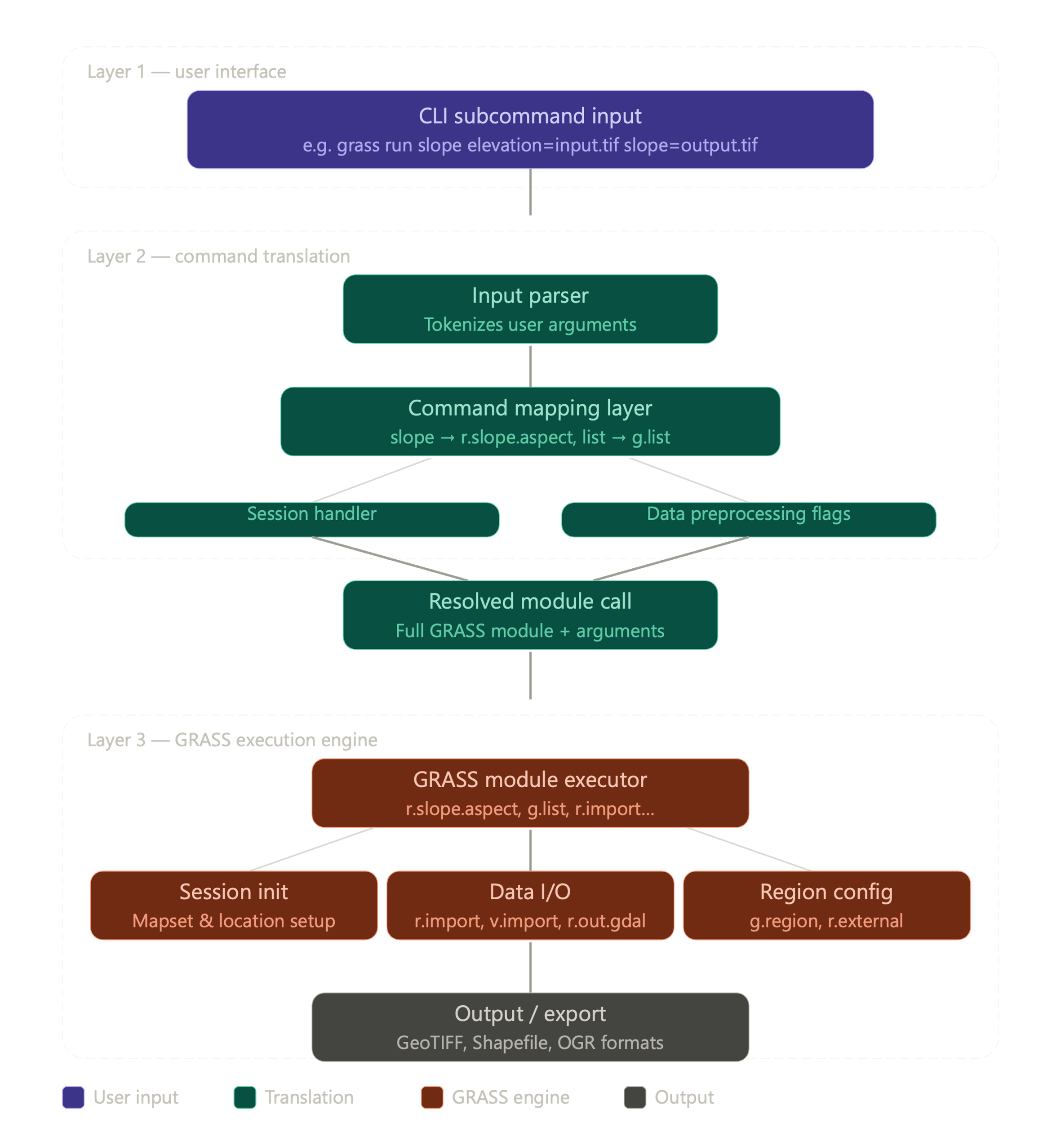

Architecture Overview Diagram

6. Benefits to the Community

The proposed Subcommand CLI significantly improves the usability and accessibility of GRASS GIS, particularly for new users and those working with quick, file-based workflows.
Currently, executing even single operations in GRASS requires multiple steps, including environment setup, data import, region configuration, module execution, and output export. This create a steep learning curve and slows down rapid experimentation.

This project addresses these challenges by enabling complete workflows to be executed in a single command. For example, users will be able to directly run analysis on GeoTIFF or GeoPackage files without manually managing sessions or intermediate steps.
AI
This has several key benefits:

Improved Accessibility: New users can start using GRASS without deep knowledge of module names, mapsets, or session management, lowering the barrier to entry.
Faster Workﬂows: Multi-step processes (import region analysis export) are reduced to a single command, improving productivity for researchers and practitioners.
Better Integration with Modern Workﬂows: The ability to directly operate on external files (GeoTIFF, GeoPackage) makes GRASS easier to integrate into scripts, pipelines, and cloud-based systems.
Consistency with Modern CLI Design: Structured subcommands align GRASS with widely adopted CLI patterns used in tools like Git and Docker, improving usability and discoverability.
Foundation for Future Extensions: The underlying Python API and modular design enable future features such as additional subcommands, workflow automation, and higher-level abstractions.

Beyond usability, this project also provides a standardized way to structure command-line interactions in GRASS, which can be extended and adopted across the ecosystem.

Deliverables
  - Required Deliverables

Structured Subcommand CLI Implementation
A production-ready extension of the experimental grass run interface that supports structured command execution for GRASS modules.
Direct File-Based Workﬂow Support
Ability to execute GRASS modules directly on GeoTIFF and GeoPackage files using integrated options such as:
--import-raster
--link-raster
--region
Command Processing Layer
A robust parsing and execution system that:
interprets subcommands and flags validates inputs
constructs execution pipelines
Python API for CLI Execution
A reusable Python abstraction layer to:
manage sessions handle workflows
execute GRASS modules programmatically
Session and Environment Automation
Automatic handling of:
GRASS initialization mapsets and locations computational region setup
Workﬂow Integration (End-to-End Execution)
Support for full workflows within a single command: import region module export
Test Suite and Validation
Unit tests for subcommands and options Integration tests for full workflows Validation of expected outputs
Documentation
CLI usage guide
examples for common workflows
developer documentation for extending subcommands

  - Optional Deliverables (If Time Permits)
Hierarchical Subcommands Support
Example:

grass raster slope.aspect grass general list
Advanced Command Mapping (Hybrid Approach)
Exploration of computed mappings instead of hardcoded aliases.
Additional Data Handling Features
support for vector workflows extended import/export options
Improved CLI Help System
Context-aware help and command suggestions.

Project Timeline (Total: 350 Hours)
Community Bonding Period (May 1 – May 24)

Date | Tasks | Deliverables
May 1 –  May 10 | Study existing GRASS CLI (grass run) and internal Python APIs (grass.script, CLI modules) | Understanding of CLI architecture
May 11 –  May 18 | Analyze current limitations, finalize feature scope (subcommands, file workflows, options like --region, --import) | Final design document
May 19 –  May 24 | Set up development + testing environment (grass.gunittest) and discuss design with mentors | Approved implementation plan

Phase 1: Core CLI Framework (May 25 – June 14)

Date | Tasks | Deliverables
May 25 –  June 1 | Implement command parsing system for grass run extensions | Basic CLI parser
June 2 – June 7 | Develop command processing layer (input validation, argument handling) | Command processing module
June 8 – June 14 | Implement basic execution pipeline (parse run module) | Minimal working CLI

Phase 2: Workflow Integration (June 15 – July 5)

Date | Tasks | Deliverables
June 15 – June 21 | Add support for --import-raster, --link-raster | File input handling
June 22 – June 28 | Implement --region handling and automatic region setup | Region automation
June 29 – July 5 | Integrate full workflow: import region module export | End-to-end execution

Midterm Evaluation (July 6 – July 10)
Core CLI + workflow execution completed Phase 3: Advanced CLI Features (July 6 – July 26)

Date | Tasks | Deliverables
July 6 – July 12 | Improve command structure and usability (better argument handling, error messages) | Refined CLI
July 13 –  July 19 | Explore structured subcommands (e.g., grass raster, grass general) | Subcommand hierarchy prototype
July 20 –  July 26 | Evaluate mapping strategies (computed vs alias-based) based on mentor feedback | Improved command system

Phase 4: Testing and Validation (July 27 – August 9)

Date | Tasks | Deliverables
July 27 – August 2 | Write unit tests for subcommands and options | Test coverage
August 3 – August 9 | Add integration tests for full workflows | Verified CLI behavior

Phase 5: Finalization and Documentation (August 10 – August 24)

Date | Tasks | Deliverables
August 10 – August 16 | Code cleanup, optimization, PR improvements | Production-ready code
August 17 – August 20 | Documentation (usage guide, examples, developer notes) | Complete documentation
August 21 – August 24 | Final PR submission and evaluation | Final submission

Time Commitment and Conflicts
I understand that this project requires a full-time commitment. I plan to dedicate approximately 35–40 hours per week throughout the coding period.
During this period, I will maintain communication with mentors and continue planning and discussions No other conflicts are expected during the coding phase

Studies
School: G H Patel College of Engineering & Technology (CVM University), Gujarat
Degree: B.Tech in Information Technology

Year: Undergraduate (Pre-final year)

Relevant Coursework:

Data Structures & Algorithms: Problem solving, optimization, and efficient system design
Operating Systems: Process management, system-level interactions, and resource handling
Computer Networks: Understanding distributed systems and communication models
Database Management Systems: Structured data handling and query optimization
Software Engineering: Designing scalable and maintainable systems

Practical Experience & Technical Alignment
Built multiple Python-based projects involving automation, machine learning, and system workflows Hands-on experience with CLI tools, scripting, and backend logic development
Developed projects involving:
End-to-end pipelines (input processing output) Model integration and execution workflows
Real-world problem solving using structured systems
Currently building AI-based and system-oriented projects focused on automation and usability

Open Source & GRASS Alignment
Set up a local GRASS GIS development environment on macOS (Apple Silicon) Worked with real dataset (nc_spm_08_grass7)
Built a working Subcommand CLI prototype, including:
command alias mapping (slope r.slope.aspect) automated execution using grass.script
full workflow (region processing export)
Successfully generated output (my_first_slope.tif) validating the pipeline Contributed to GRASS ecosystem:
Opened issues and pull requests in grass-addons repository
Gained familiarity with project structure, contribution workflow, and review process

Relevance to This Project
This project directly aligns with my interest in:

Improving developer experience through better interfaces Simplifying complex systems using abstraction layers
Designing practical tools that reduce friction in real workflows

My background in system design and hands-on experimentation with GRASS CLI has helped me identify real usability gaps. This proposal builds on that experience to create a more intuitive and efficient command-line interface for GRASS GIS, making it more accessible to both new and advanced users.

Biographical Information
I am an undergraduate student pursuing a B.Tech in Information Technology at G H Patel College of Engineering & Technology (CVM University). My primary interest lies in building practical systems that simplify complex workflows and improve usability for developers and end users.
Over time, I have developed strong experience working with Python, system-level scripting, and building end-to-end applications. I have worked on multiple projects involving automation, machine learning pipelines, and real-world problem solving, where I focused on designing clean execution flows and reducing unnecessary complexity in systems.
Recently, I explored GRASS GIS in depth by setting up a local development environment on macOS (Apple Silicon) and working with real datasets such as nc_spm_08_grass7. Instead of limiting myself to documentation, I built a working prototype that simplifies GRASS CLI usage through subcommand mapping and automated execution. This prototype allows commands like:
g slope elevation=input.tif slope=output.tif

to internally execute GRASS modules such as r.slope.aspect, along with handling region setup and exporting results. I validated the full pipeline by generating output files successfully, which gave me a strong understanding of how GRASS modules, sessions, and Python APIs interact.
In addition, I have contributed to the GRASS ecosystem by working on issues and pull requests in the grass-addons repository. This experience helped me understand the project structure, contribution workflow, and expectations from maintainers.

Relevant Skills
Languages: Python, C++, Java, JavaScript, SQL Technologies: Git, Linux, CLI tools, basic Docker usage Core Strengths:
System design and workflow automation CLI tool development and scripting
Debugging and understanding existing codebases Building practical, usable solutions

Why I Am a Good Fit for This Project
This project is not just about implementing features—it is about improving how users interact with GRASS GIS. My approach has been hands-on from the beginning:
I identified usability friction in the current CLI
Built a working prototype instead of just proposing ideas
Engaged with the system at both user and implementation levels This gives me a clear understanding of both:
what needs to be improved, and
how to implement it realistically within the existing architecture

I am confident in my ability to take this project from a working prototype to a well-designed, tested, and production- ready CLI system.

GSoC History
This is my first time applying to Google Summer of Code.

I have chosen to focus exclusively on the GRASS GIS project and have not applied to any other organizations. Over the past few weeks, I have dedicated time to understanding the codebase, setting up a working development environment, building a functional prototype, and engaging with mentors through discussions and contributions.
My decision to apply only to GRASS GIS reflects my commitment to this project and my intention to contribute meaningfully rather than treating GSoC as a broad application process.

AI Tool Disclosure
I used AI tools (such as ChatGPT and Claude) as development assistants during the initial stages of this project. These tools helped with debugging environment setup, understanding GRASS CLI behavior, and refining the structure and clarity of this proposal.
All core ideas, design decisions, and implementation work—including the CLI prototype, command mapping logic, and workflow execution—were developed and tested by me. I have a clear understanding of the system and can explain all aspects of the implementation in detail.
AI tools were used only as supportive aids for productivity and clarity, not as a substitute for original work.

References
- GRASS GIS Documentation — Command Line Interface https://grass.osgeo.org/grass-stable/manuals/index.html

- GRASS GIS Python Scripting Library (grass.script) https://grass.osgeo.org/grass-stable/manuals/libpython/script_intro.html

- GRASS GIS Experimental CLI (grass run) Source https://github.com/OSGeo/grass/tree/main/python/grass/app

- GRASS GIS Modules Documentation (e.g., r.slope.aspect, g.list) https://grass.osgeo.org/grass-stable/manuals/

- Git CLI Design Documentation (for structured subcommands) https://git-scm.com/docs

- Docker CLI Design Reference https://docs.docker.com/engine/reference/commandline/cli/

